TEUTONIC (prewar) EXCELENCE
(I chose to show two guns, one sidelock and one boxlock which are both of quite unique design)

It is very difficult for someone to be objective and impartial whenever you have to express an opinion on things, close to one’s heart. I have had an English academic education and afterwords a training in gunmaking in one of the top London Gunmakers for a while. All that back in the seventies. Those days, any gun that wasn’t British was not even worth to talk about and following that chain of argument, anything that wasn’t a sidelock was disregarded. The same was true for anything which was not made in London. These were notions deeply hammered home in my mind for a long time even after I left England and set shop here in Athens.
Having had an intimate inside knowledge and appreciation of quality, I thought why not, to make use of it. So I started buying guns from mainly the two prime London auction houses, doing every time whatever was necessary to bring them back to originality, and selling them over here. Naturally the guns where only English. Those days in the London Sales, the foreign guns where very few and far between and bar for very few exceptions sneered upon.

In one of my buying travels I found myself in Lincolnshire visiting a friend and colleague and also doing some wildfowling. Taking a day trip to a nearby small town, I visited a local gunshop in a chance of finding anything worth buying. I did find one or two guns and made a deal with the owner, and then I saw a carton barrel tucked away in a dark corner behind a door of the shop. Inside, there were stacked, barrel down, about twenty guns. I asked the man what they were, and the reply was “Oh cheap stuff, odds and sods”.
When I started fumbling my eye fell on something completely strange and unusual. I pulled it out. It was full of dust and dirt and with a bit of very light surface rust. I had a closer look. It was a sixteen bore. Everything on it, radiated quality. I asked the guy what it was. He said “Oh some Gerry rubbish”. Then I asked how much he wanted for it and he quoted a ridiculously small amount, to which I agreed immediately and the gun came home with me. I cleaned the barrels and read the makers name SAUER & SOHN. When eventually I took the gun apart, I was astounded by the quality of the work. This was a revelation to me some thirty-five years ago. It was as good as any London best. It did need a lot of careful work in refinishing. When it was all done it was sold to a very dear, long departed, friend of mine. A high ranking naval officer and devoted shooting man, oddly enough and himself trained in several naval schools in England, and also in a possession of an English wife. The gun since his unfortunate early death was passed on to his son, also a friend and shooting companion of mine, from whom I borrowed it for photographing.

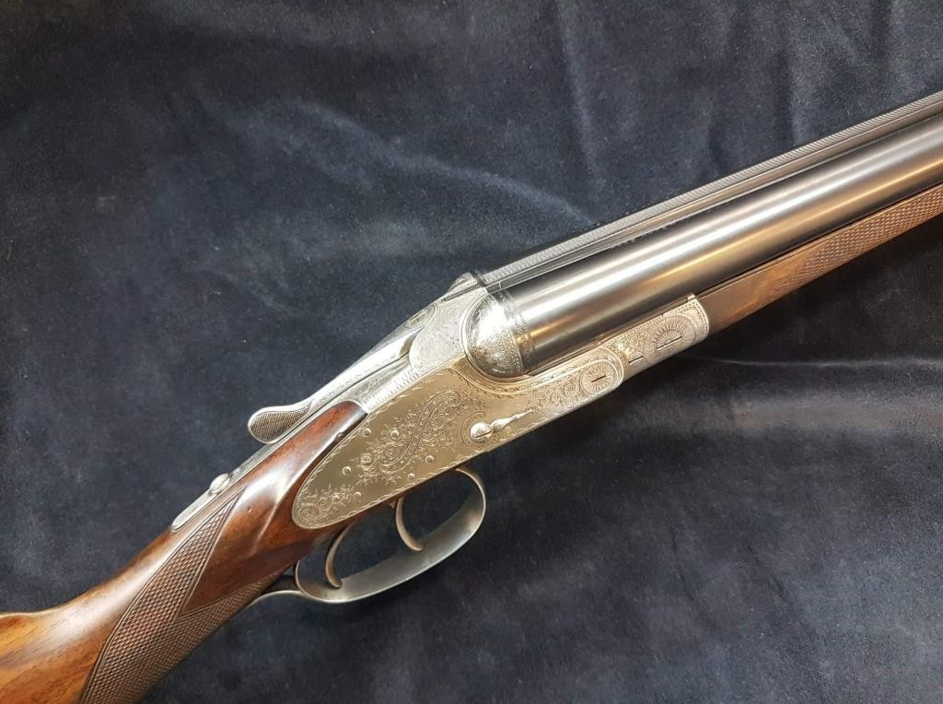
The beautiful little 16 bore. Note the clock finger like cocking indicators. There is no excuse with these to say “I didn’t know my gun was cocked”
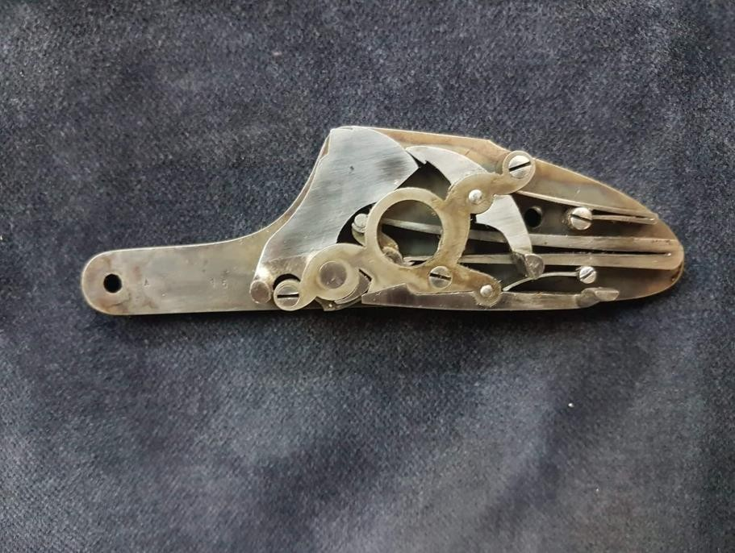
The unique lock

“It is very ease to replace an old establish design with a new one, it is damn difficult the new design to be better from the old one” (My axiom after forty odd years in the trade).
Well in this gun the shaping of the Action and the lockwork are absolutely original and despite the fact that they are very demanding in workmanship, there are as efficient as any other mechanism. Note the fact that this is a back action sidelock but due to its innovative

Thank you for using www.freepdfconvert.com service!

Only two pages are converted. Please Sign Up to convert all pages. https://www.freepdfconvert.com/membership

